31.58: a) For 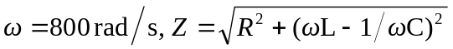
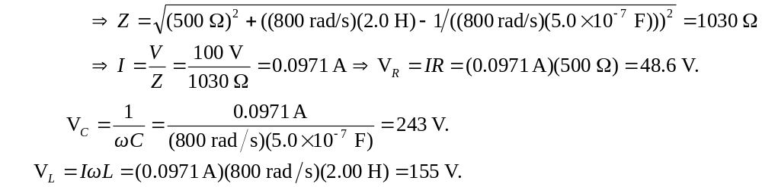
Also note 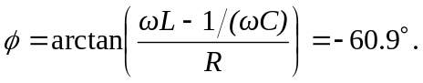

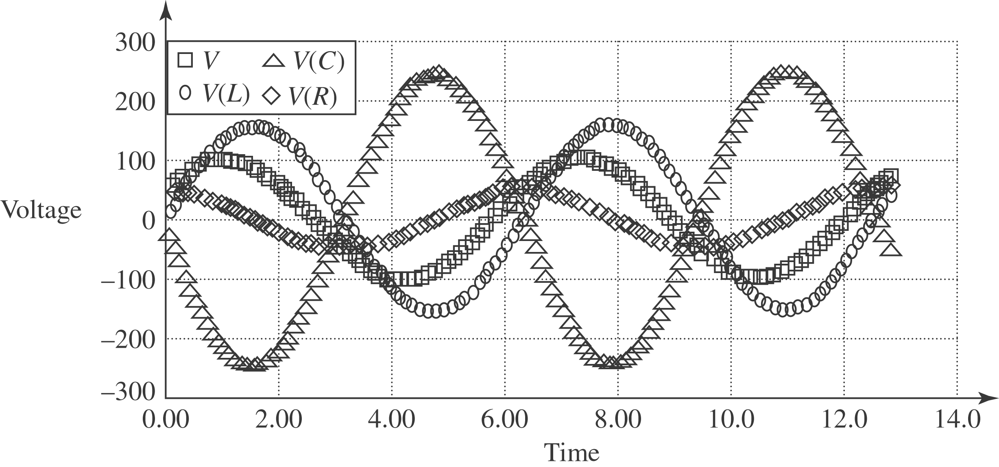

b) Repeating exactly the same calculations as above for

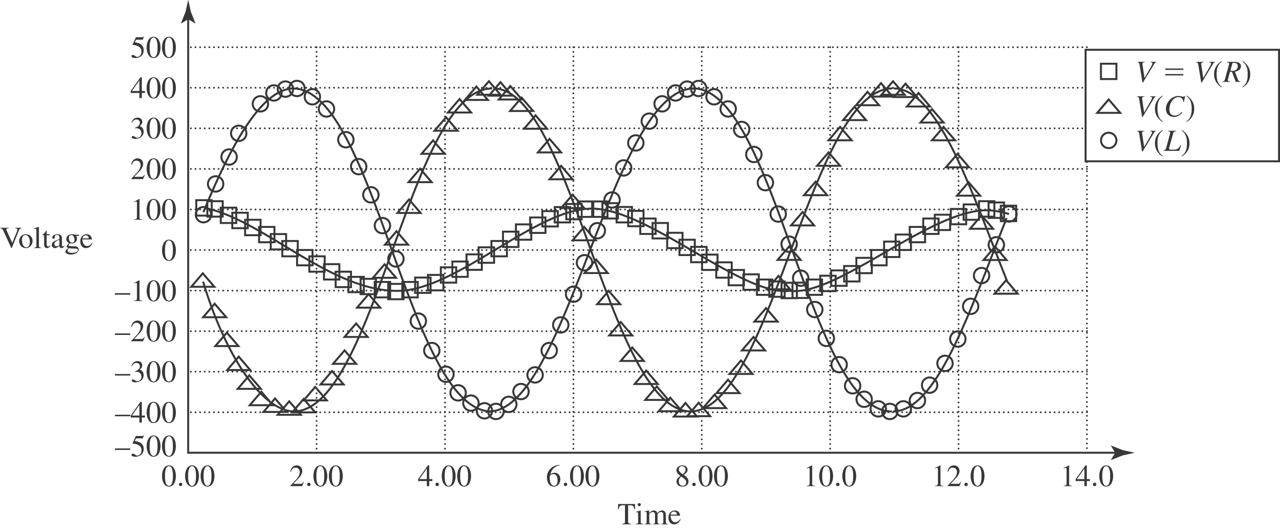

c) Repeating exactly the same calculations as part (a) for
